**Assignment 1**

**Fundamentals of Programming**

**CS-114**  **FALL 2023**

**Name: Fiza Ali**

**CMS: 454685**

**Class: AE-1**

**Task 1:**

Write a C++ program, take two strings as input from user and check if both strings

are equal or not. If they are equal make them unequal by rotating string. e.g., Hello

is turned into olleH etc

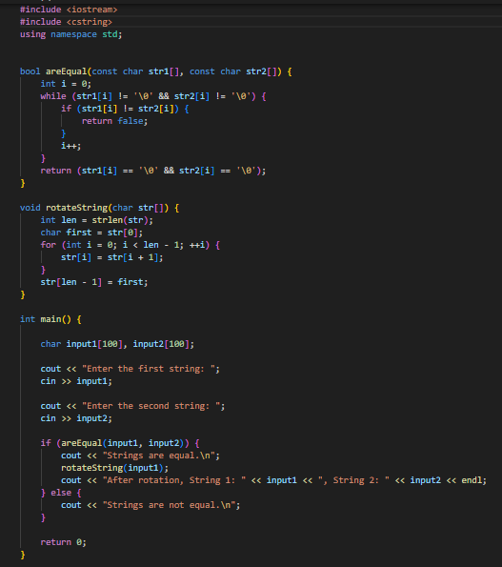

**Output**:

**Task 2:**

Write a C++program for a string which may contain lowercase and uppercase

characters. The task is to remove all duplicate characters from the string and find

the resultant string

**Output:**



**Task 3:**

Suppose an integer array a[5] = {1,2,3,4,5}. Add more elements to it and display

them in C++.

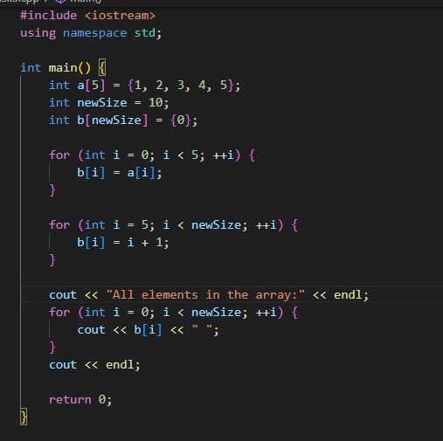

**Output:**



**Task 4:**

Write a C++ program that uses a while loop to find the largest prime number less

than a given positive integer N. Your program should take the value of N as input

from the user and then find the largest prime number less than or equal to N. You

are not allowed to use any library or pre-existing functions to check for prime

numbers.

**Output**:

**Task 5:**

Implement Bubble Sort on an array of 6 integers. 5

**OUTPUT:**



**Task 6:**

Solve any Aerospace/Real Life Problem using C++ Programming.

Height change simulator of Aircraft:

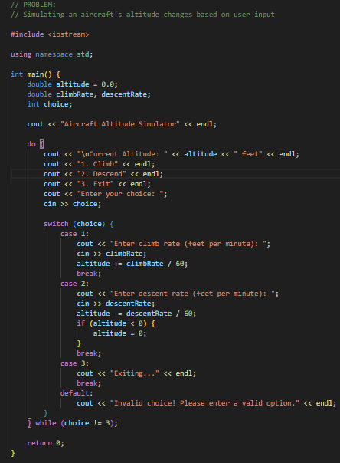

**Output:**

